Assignment -2
Flask Assignment

Assignment Date | 17/11/2022
Student Name | Ashok Kaushik
Student Roll Number | 19BCS059
Maximum Marks | 2 Marks

- 1. Create User table with user with email, username, roll number, password.

SQL query:
CREATE database IBM
USE IBM
CREATE TABLE User(email varchar(50),username varchar(50),rno integer(5),password varchar(20));

OUTPUT:
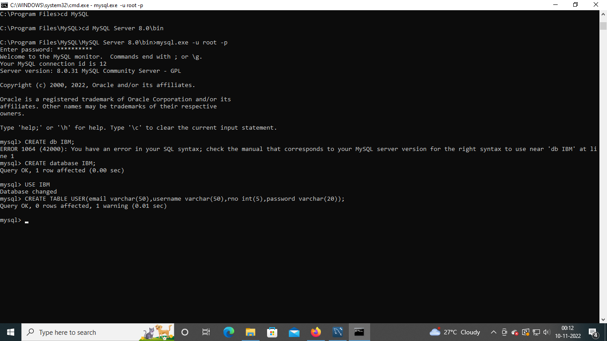
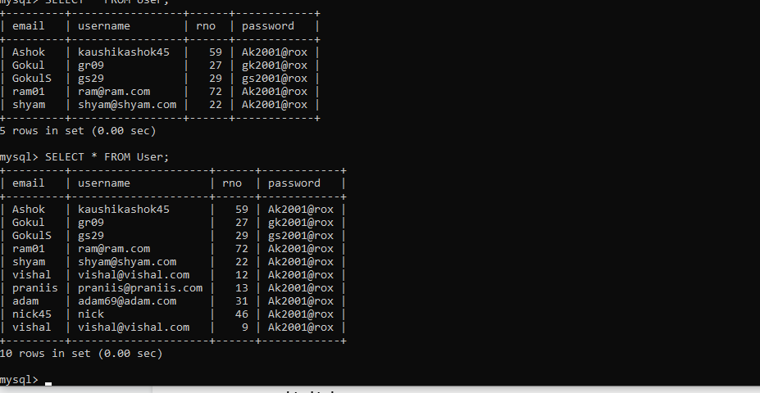

2. Perform UPDATE,DELETE Queries with user table

SQL Query:
UPDATE Users SET username=”ss29” WHERE rno=39;
DELETE FROM User WHERE rno=39;

OUTPUT:
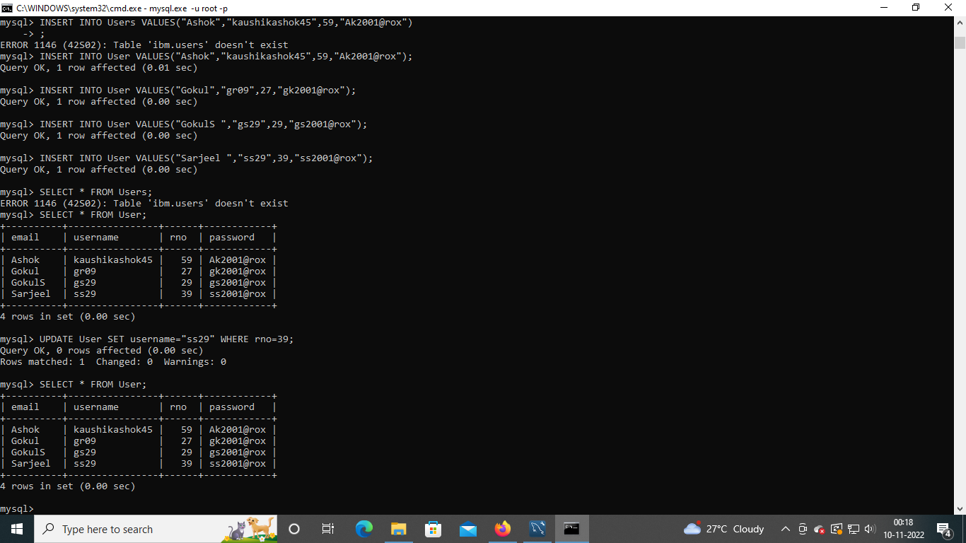

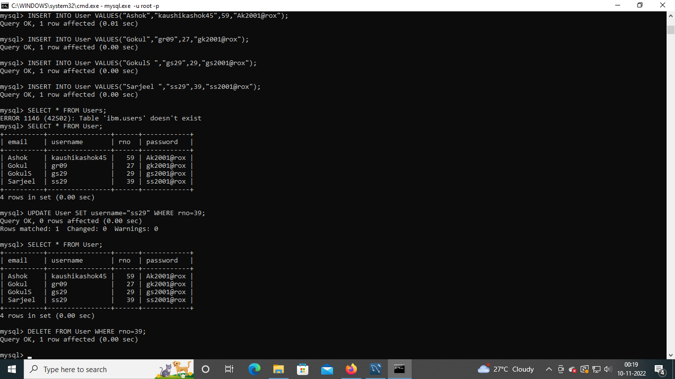

3. Connect python code to db2.

connecting python to sql
app.py

from flask import Flask, render_template, request, redirect, url_for, session
from flask_mysqldb import MySQL
import MySQLdb.cursors
app = Flask(__name__)
app.secret_key = 'Ak2001@rox'

app.config['MYSQL_HOST'] = 'localhost'
app.config['MYSQL_USER'] = 'root'
app.config['MYSQL_PASSWORD'] = 'Ak2001@rox'
app.config['MYSQL_DB'] = 'IBM'

mysql = MySQL(app)

@app.route('/', methods=['GET', 'POST'])
def index():
if request.method == "POST":
details = request.form
username = details['username']
email = details['email']
password=details['password']
rno=details['rno']
cur = mysql.connection.cursor()
cur.execute("INSERT INTO User(email,username,rno,password) VALUES (%s, %s,%s,%s)", (username,email,rno,password))
mysql.connection.commit()
cur.close()
msg="registered successfully"
return render_template('login.html',msg=msg)
return render_template('index.html')

@app.route('/')
@app.route('/welcome', methods =['GET', 'POST'])
def welcome():
msg = 'logged in successfully'
return render_template('welcome.html', msg = msg)
@app.route('/login', methods =['GET', 'POST'])
def login():
msg = ''
if request.method == 'POST' and 'username' in request.form and 'password' in request.form:
username = request.form['username']
password = request.form['password']
cursor = mysql.connection.cursor(MySQLdb.cursors.DictCursor)
cursor.execute('SELECT * FROM User WHERE username = % s AND password = % s', (username, password, ))
account = cursor.fetchone()
if account:
session['loggedin'] = True
session['id'] = account['rno']
session['username'] = account['username']
msg = 'Logged in successfully !'
return render_template('welcome.html', msg = msg)
else:
msg = 'Incorrect username / password !'
return render_template('login.html', msg = msg)

@app.route('/logout')
def logout():
session.pop('loggedin', None)
session.pop('id', None)
session.pop('username', None)
return redirect(url_for('login'))

if __name__ == '__main__':
app.run()
register.html
<html>
<head>
<title>Registration Page </title>
</head>
<body>
<form action="http://127.0.0.1:5000//register" method="POST">
<h1> Registration Form </h1>
<p> Enter your name : <input type="text" name="name"/></p>
<p> Enter your mail id: <input type="email" name="mail"/></p>
<p> Enter your phone number:<input type="number" name="phone"/></p>
<p> <input type="submit" value="submit"></p>
</form>
</body>
</html>

app.py
from flask import Flask,redirect,url_for,request
app=Flask(__name__)
@app.route('/success/<string:name>/<string:mail>/<string:phone>')
def success(name,mail,phone):
return "Name: " + name +" <br> Mail ID: "+mail+" <br> Phone number: "+phone

@app.route('/register',methods=['POST'])
def register():
if request.method=='POST':
user=request.form['name']
mailid=request.form['mail']
phonum=request.form['phone']
return redirect(url_for('success',name=user,mail=mailid,phone=phonum))

if __name__=='__main__':
app.run(debug=True)

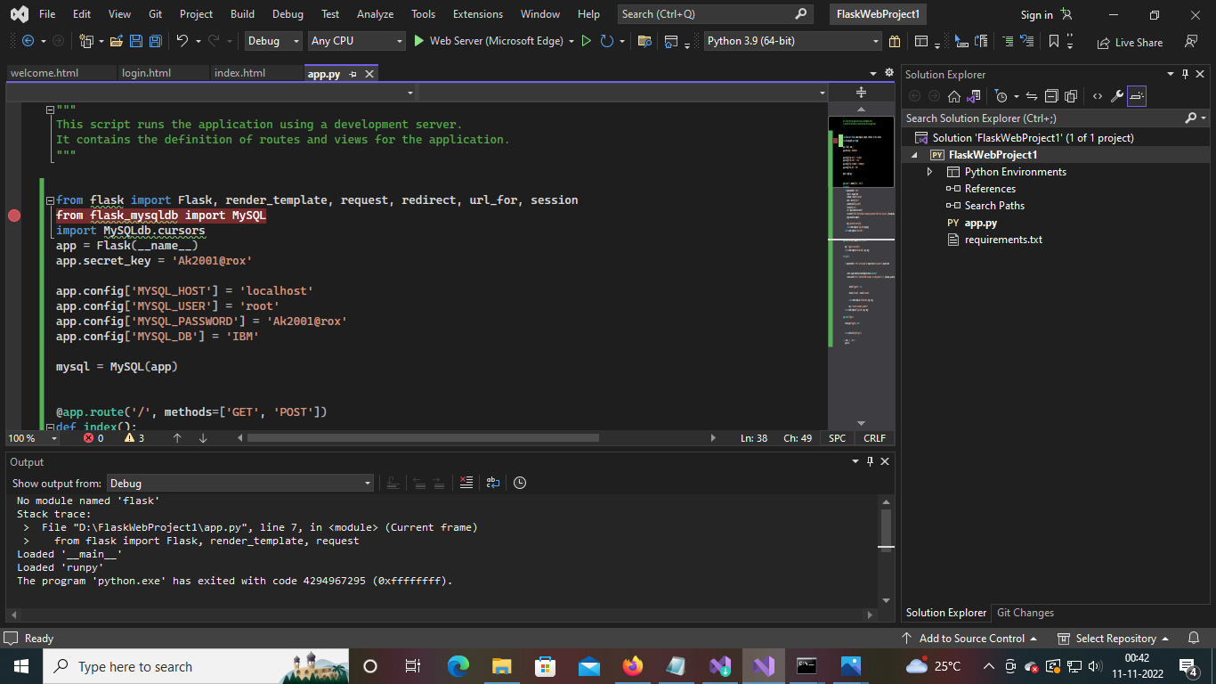

4. Create a flask app with registration page, login page and welcome page. By default load the registration page once the user enters all the fields store the data in database and navigate to login page authenticate user username and password. If the user is valid show the welcome page

index.html(for registration):

<HTML>
<BODY bgcolor="cyan">
<form method="POST" action="">
<center>
<H1>Enter your details </H1> <br>
Username <input type="text" name="username" /> <br>
Email <input type="text" name="email" /> <br>
Roll no <input type="number" name="rno" /> <br>
Password <input type="text" name="password" /> <br>
<input type="submit">
</center>
</form>
</BODY>
</HTML>

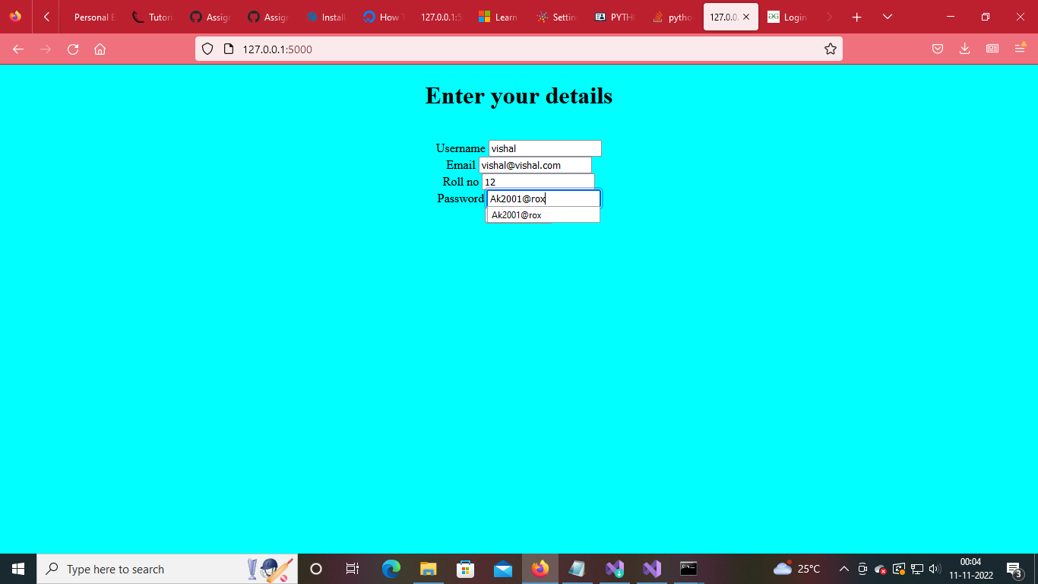
login.html(for login):

<html>
<head>
<meta charset="UTF-8">
<title> Login </title>
<link rel="stylesheet" href="{{ url_for('static', filename='style.css') }}">
</head>
<body>
</br></br></br></br></br>
<div align="center">
<div align="center" class="border">
<div class="header">
<h1 class="word">Login</h1>
</div></br></br></br>
<h2 class="word">
<form action="{{ url_for('login') }}" method="post">
<div class="msg">{{ msg }}</div>
<input id="username" name="username" type="text" placeholder="Enter Your Username" class="textbox" /></br></br>
<input id="password" name="password" type="password" placeholder="Enter Your Password" class="textbox" /></br></br></br>
<input type="submit" class="btn" value="Sign In"></br></br>
</form>
</h2>
<p class="bottom">Don't have an account? <a class="bottom" href="{{url_for('index')}}"> Sign Up here</a></p>
</div>
</div>
</body>
</html>
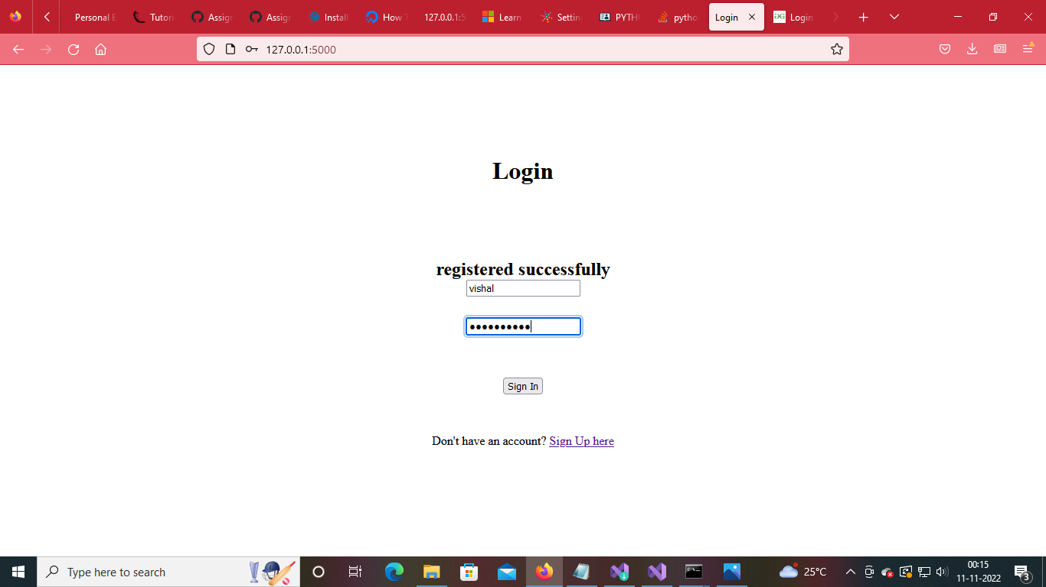
welcome.html(welcome page):

<!DOCTYPE html>

<html lang="en" xmlns="http://www.w3.org/1999/xhtml">
<head>
<meta charset="utf-8" />
<title>Welcome {{session.username}}</title>
</head>
<body>
<center>
<H1>Welcome {{session.username}}</H1>
</center>
</body>
</html>
